NAME : SAI SAKETH THELU

ROLL NO : 2403A54082

BATCH : 03 (DS)

Task Assignment 1:

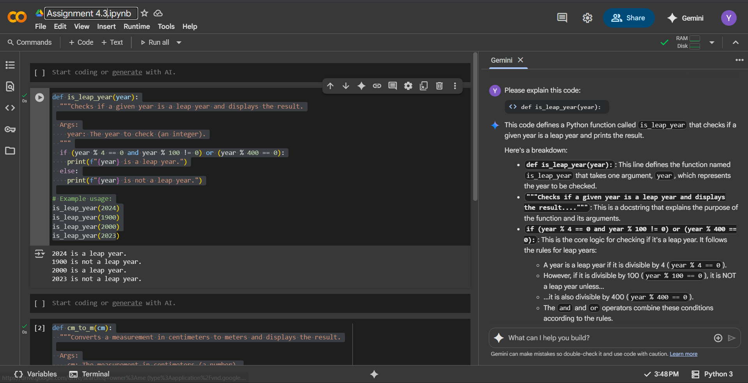

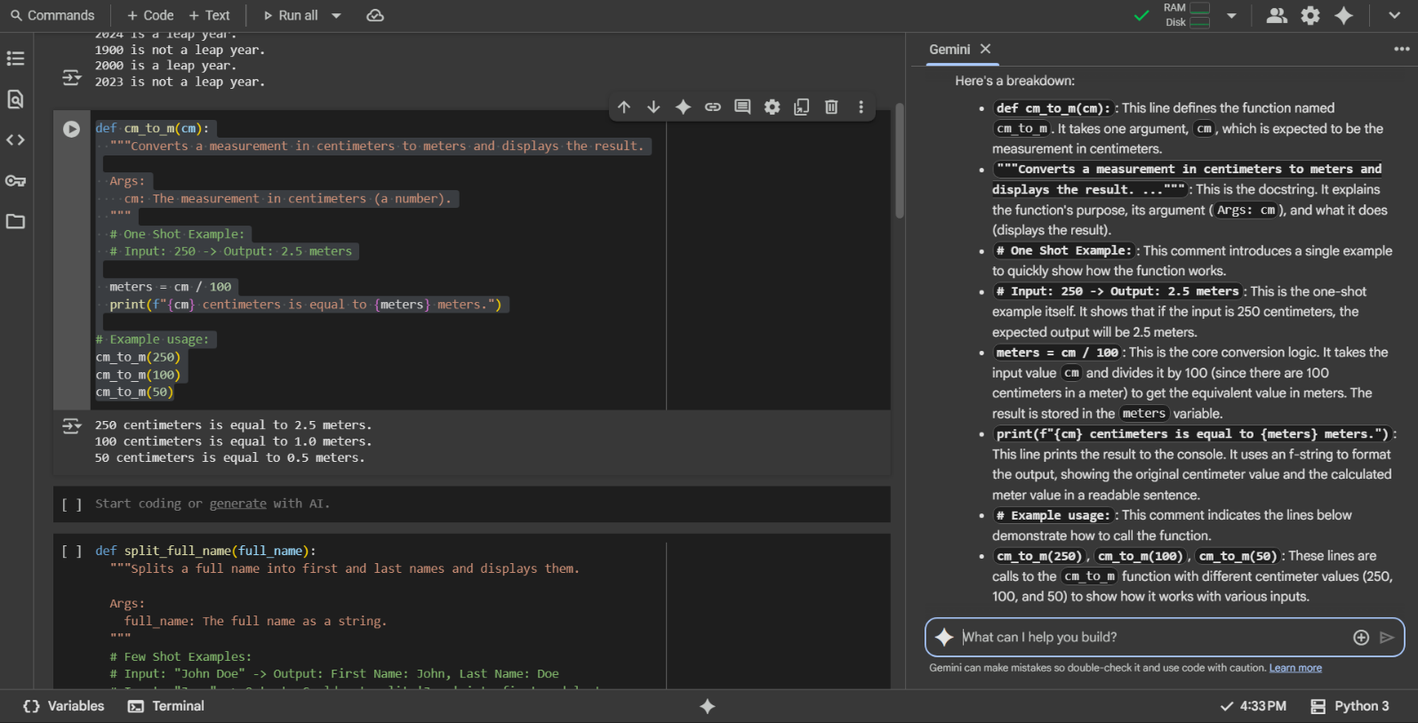Task Assignment 2:

Task Assignment 3:

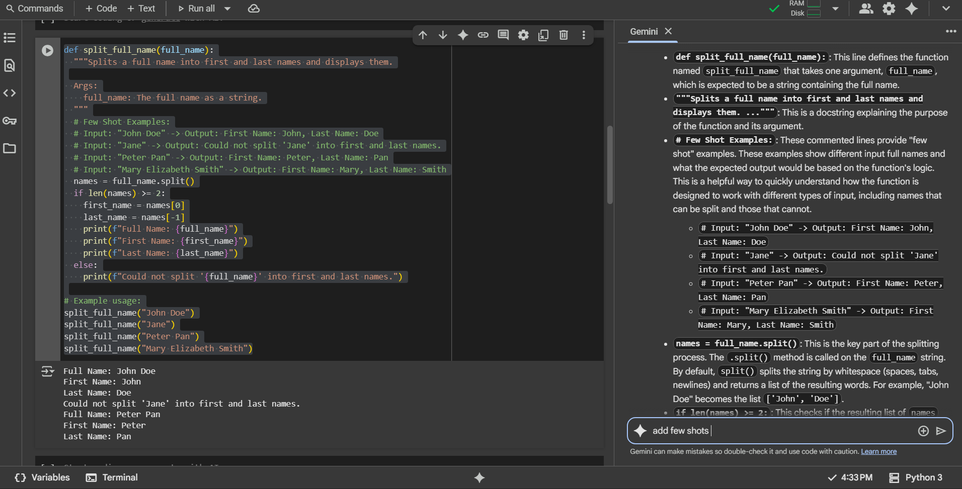

Task Assignment 4:

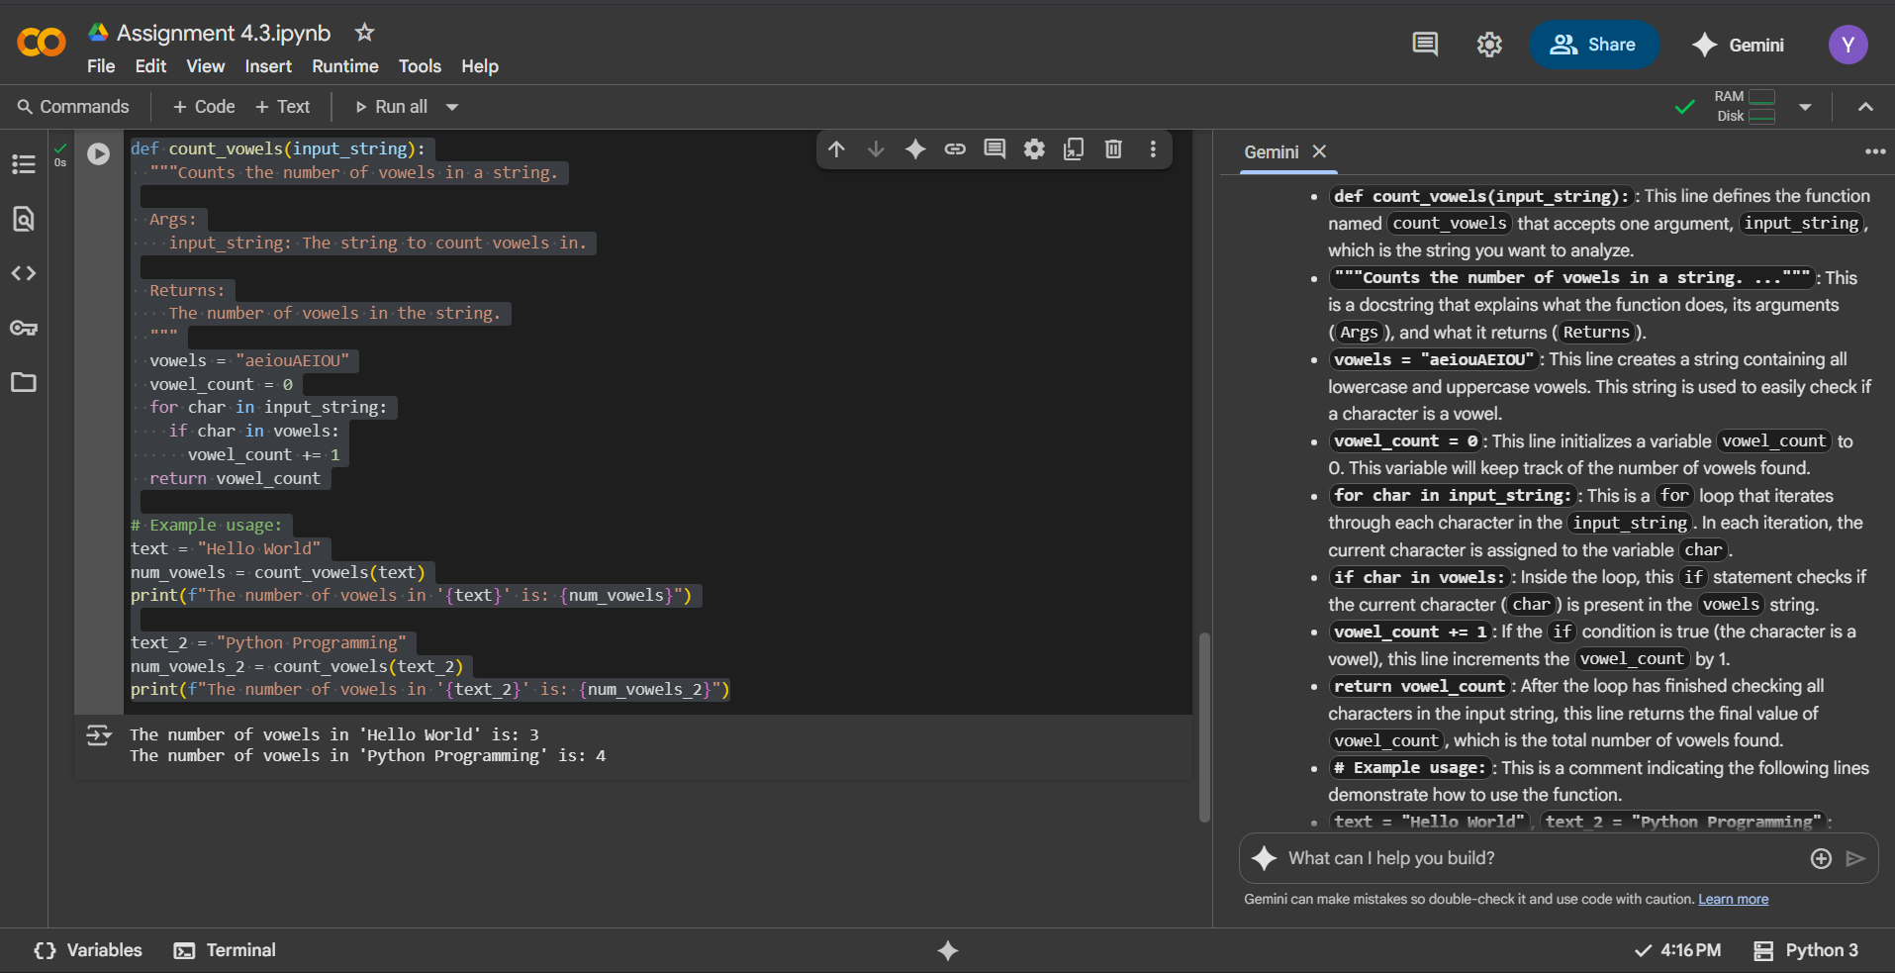

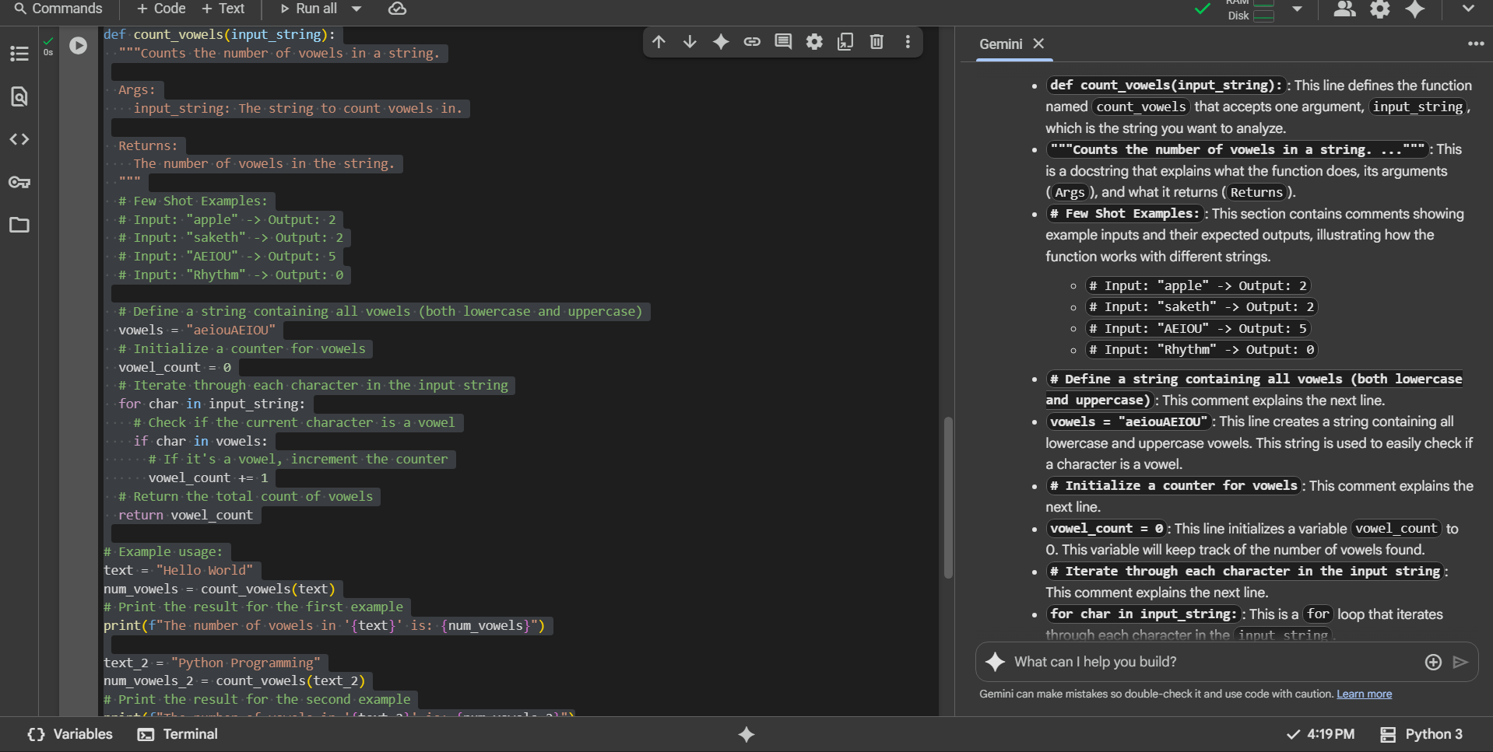

Task Assignment 5:

